Table of Contents

**Introduction** **1**

1.1 Introduction to Virtual and Augmented Reality 1

1.3 Objective **3**

**Literature Survey** **3**

2.1 Literature 3

2.1.1 History 3

2.2 Components of Augmented Reality 4

2.3 Types of Augmented Reality 5

2.4 Applications of Augmented Reality 7

2.5 Applications of Virtual Reality **10**

**Requirements and Analysis** **10**

3.1. Functional and Nonfunctional Requirements 10

3.2. Constraints 11

3.3. Hardware and Software Requirements 11

3.4. Analysis **13**

**Design** **13**

4.1. Architecture 13

4.2. Detailed Design 14

4.2.1 System Design 14

4.2.2 Flow Chart 15

4.2.3 State Transition Diagram 16**17**

**Implementation** **17**

5.1 Implemented System 17

5.2 Code Snippets 19

**Conclusion** **38**

**References** **39**

**Chapter Ⅰ**

# **Introduction**

## **1.1 Introduction to Virtual and Augmented Reality**

Virtual Reality is a computer simulated reality which replicates a real environment, and simulate a user's physical presence in this environment while Augmented Reality blurs the line between what's real and what's computer-generated by enhancing what we see, hear and feel. Augmented Reality (AR) is a variation of Virtual Environments (VE), or Virtual Reality (VR) as it is more commonly called. VR technologies completely immerse a user inside a synthetic environment. While immersed, the user cannot see the real world around him. In contrast, AR allows the user to see the real world, with virtual objects superimposed upon or composited with the real world. Therefore, AR supplements reality, rather than completely replacing it[1].

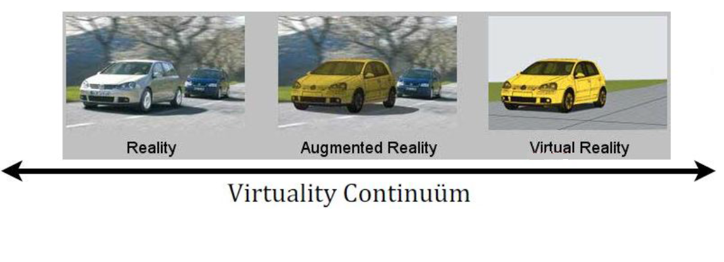

Fig 1.1 Virtuality Continuum [4]

**1.2 Problem Statement**

The traditional methods of experiencing the real world are becoming outdated day by day. With rapidly changing technology, people don't want to just see the world but also interact with it. They want to have first hand experience in learning which is possible through virtual and augmented reality.For both AR and VR, the benefits over traditional approaches are much more than just better retention and a deeper understanding. Because the technology is also interactive, the technology can be used to test and evaluate understanding and reward users who master concepts before moving on. By integrating testing into the environment itself, the content can be highly tuned and even customised based on the learning style, background or even by how fast the student is learning. The proposed android application “Exploration” will have various functionalities like providing 3d view of different tourist places objects around you in the real world and also help students to view 3d complex structure in real world which would be difficult to imagine.

## **1.3 Objective**

The objective of the proposed project is to provide a more immersive and interactive environment to the user to learn about different things. The projected virtual objects display details that are difficult to imagine by the user. The information conveyed by the virtual objects helps a user perform real-world tasks. “Exploration” will help to inculcate learning and provide amazing experience to kids as well as adults. It will provide them a whole new look towards virtual world using Virtual and Augmented Reality.

# **Chapter Ⅱ**

# **Literature Survey**

## **2.1 Literature**

Augmented Reality is the seamless fusion of the real world with generated virtual artefacts superimposed onto our view through the device. Virtual Reality (VR) technologies completely immerse a user inside a synthetic environment. While immersed, the user cannot see the real world around him. Virtual environment needs Head Mounted devices to be seen , while Augmented Reality can be seen in the real world using the application it is built on .

### **2.1.1 History**

* In 1968, Ivan Sutherland developed the first head-mounted display system.
* In 1974, Myron Krueger built an ‘artificial reality laboratory called the video place which combined projectors with video cameras that emitted onscreen silhouettes, surrounding user in an interactive environment.
* In 1990, Boeing Researcher Tom Caudell coined the term “Augmented Reality”.
* In 1994, Julie Martin the first augmented reality Theater production, “Dancing in Cyberspace”, featuring acrobats who danced within and around virtual objects on their physical stage.
* In 1999, Naval researchers begin working on Battlefield Augmented Reality System[BARS], the robust, original model of early wearable units for soldiers.
* In 2009, print media “Esquire Magazine” tried out AR, in which it prompted readers to scan the cover to make Robert Downey Jr. come alive

## **2.2 Components of Augmented Reality**

Augmented reality systems are built upon on three major buildings blocks [4]:

1. Tracking and Registration

Tracking and Registration is needed to know the user’s exact location in comparison to his surroundings and also is used for tracking the exact eye and head movements of the user. This is the most complex part of the Augmented Reality technology as three major functions such as tracking the overall location, movement of the user’s head and eye and adjusting the graphics to be displayed are done with utmost precaution.

1. Display technology

Types of displays are used in AR technology

* Head Mounted Displays [HMD]

HMD keeps both the images of the real physical world and the virtual graphical world over the user’s world view.

* Handheld Displays

Such displays are small in size and will easily fit in one hand. These devices use video transparent techniques to relate the virtual world to the real world.Since they are easily portable and due to the bulk use of camera phones, they are used widely.

1. Real time rendering

Real time rendering means as the orientation of the target object changes in the real world, the orientation of the projected 3d object should also change simultaneously without any flickering.

## 

## 

## **2.3 Types of Augmented Reality**

* Projection Based AR *-*

Projection based augmented reality works by projecting artificial light onto real world surfaces[1]. Projection based augmented reality applications allow for human interaction by sending light onto a real world surface and then sensing the human interaction (i.e. touch) of that projected light. Detecting the user’s interaction is done by differentiating between an expected (or known) projection and the altered projection (caused by the user's interaction). Another interesting application of projection based augmented reality utilizes laser plasma technology to project a three-dimensional (3D) interactive hologram into mid-air.

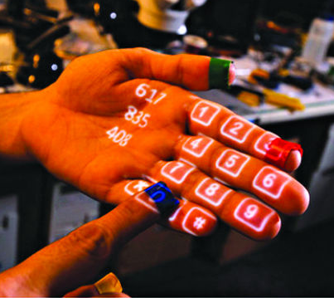

Fig 2.3.1 Projection based AR

* Recognition Based AR -

Recognition based AR focuses on recognition of objects and then provide us more information about the object. e.g. when using your mobile phone to scan a barcode or QR code, you actually use object recognition technology. Fact is, except location based AR systems, all other types do use some type of recognition system to detect the type of object over which augmentation has to be done.Recognition based AR technology has varied uses as well. One of them is to detect the object in front of the camera and provide information about the object on screen. This is something similar to the AR apps for travellers (location browsers). However, the difference lies in the fact that the AR location browsers usually do not know about the objects that they see while recognition based AR apps do.

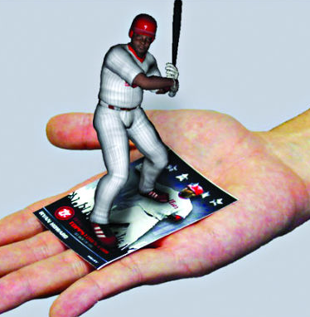

Fig 2.3.2 Recognition based AR

* Location Based AR -

As one of the most widely implemented applications of augmented reality, markerless (also called location-based, position-based, or GPS) augmented reality, uses a GPS, digital compass, velocity meter, or accelerometer which is embedded in the device to provide data based on your location. A strong force behind markerless augmented reality technology is the wide availability of smartphones and location detection features they provide. It is most commonly used for mapping directions, finding nearby businesses, and other location-centric mobile applications.[1]

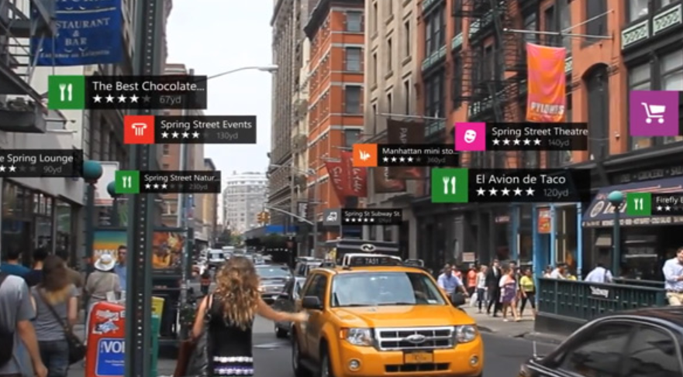

Fig 2.3.3 Location based AR

* Superimposition Based AR -

Superimposition based augmented reality either partially or fully replaces the original view of an object with a newly augmented view of that same object. In superimposition based augmented reality, object recognition plays a vital role because the application cannot replace the original view with an augmented one if it cannot determine what the object is.

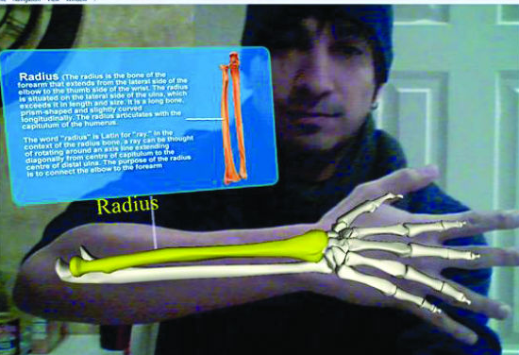

Fig 2.3.4 Superimposition based AR

## **2.4 Applications of Augmented Reality**

* Education

New possibilities for teaching and learning provided by AR have been increasingly recognized by educational researchers. The coexistence of virtual objects and real environments allows learners to visualize complex spatial relationships and abstract concepts , experience phenomena that is not possible in the real world , interact with two and three dimensional synthetic objects in the mixed reality , and develop important practices that can not be developed and enacted in other technology-enhanced learning environments . These educational benefits have made AR one of the key emerging technologies for education over the next five years [4].

* Military AR Uses

The Heads-Up Display (HUD) is the typical example of augmented reality when it comes to military applications of the technology. A transparent display is positioned directly in the fighter pilot's view. Data typically displayed to the pilot includes altitude, airspeed and the horizon line in addition to other critical data. The term "heads-up" name applies because the pilot doesn't have to look down at the aircraft's instrumentation to get the data he needs.

The Head-Mounted Display (HMD) is used by ground troops. Critical data such as enemy location can be presented to the soldier within their line of sight. This technology is also used for simulations for training purposes.

* Medical AR Uses

Medical students use AR technology to practice surgery in a controlled environment. Visualizations aid in explaining complex medical conditions to patients. Augmented reality can reduce the risk of an operation by giving the surgeon improved sensory perception. This technology can be combined with MRI or X-ray systems and bring everything into a single view for the surgeon.[2][4]

Neurosurgery is at the forefront when it comes to surgical applications of augmented reality. The ability to image the brain in 3D on top of the patient's actual anatomy is powerful for the surgeon. Since the brain is somewhat fixed compared to other parts of the body, the registration of exact coordinates can be achieved. Concern still exists surrounding the movement of tissue during surgery. This can affect the exact positioning required for augmented reality to work.

* AR Apps for Navigation

Navigation applications are possibly the most natural fit of augmented reality with our everyday lives. Enhanced GPS systems use augmented reality to make it easier to get from point A to point B.

Using the smartphone's camera in combination with the GPS, users see the selected route over the live view of what is in front of the car.

* AR Gaming

With recent advances in computing power and technology, gaming applications in augmented reality are on the upswing. Head-worn systems are affordable now and computing power is more portable than ever. Before you can say "Pokemon Go," you can jump into an AR game that works with your mobile device, superimposing mythical creatures over your everyday landscape.

Popular Android and iOS AR apps include Ingress, SpecTrek, Temple Treasure Hunt, Ghost Snap AR, Zombies, Run! and AR Invaders.

## **2.5 Applications of Virtual Reality**

* Education

Education is area which has adopted virtual reality for teaching and learning situations. The advantage of this is that it enables large groups of students to interact with each other as well as within a three dimensional environment.

It is able to present complex data in an accessible way to students which is both fun and easy to learn. Plus these students can interact with the objects in that environment in order to discover more about them.For example, astronomy students can learn about the solar system and how it works by physical engagement with the objects within. They can move planets, see around stars and track the progress of a comet. This also enables them to see how abstract concepts work in a three dimensional environment which makes them easier to understand and retain.

* Health Care

Healthcare is one of the biggest adopters of virtual reality which encompasses surgery simulation, phobia treatment, robotic surgery and skills training.

One of the advantages of this technology is that it allows healthcare professionals to learn new skills as well as refreshing existing ones in a safe environment. Plus it allows this without causing any danger to the patients.

* Virtual Reality and Heritage

This refers to the use of virtual reality in museum and historical settings, e.g. visitor centres. These settings employ interaction as a means of communicating information to the general public in new and exciting ways.There has been a move away from the traditional type of experience associated with museums, galleries and visitor centres. Children are often difficult to attract to a museum or gallery as they tend to see this as a boring experience. But the use of interactive technologies such as virtual reality has changed that perception and opened up these spaces to a new audience.

* VR in the film industry

For the film industry rather than just being a spectator looking at the screen you could feel, see and hear what is going on around you. Other sensory tools could also be added such as smells and more intense touch such as soft, cold, hot to give you a more realistic experience. In the medical field it could enable training practitioners to perform surgeries and medical care before they are introduced to real patients. The possibilities for the future of virtual reality are endless.

# **Chapter Ⅲ**

# **Requirements and Analysis**

## **3.1. Functional and Nonfunctional Requirements**

* Hardware Functional Requirements
  + The device shall be wireless to make portable to use.
  + The device shall provide a minimum 85 degree field of vision in both directions (vertical and horizontal) where AR content can be displayed.
  + The device shall work in ambient temperatures up to 50 degree celsius
  + The device shall have an accelerometer, eye tracking and gyroscope that provides information to the software about gaze, and position.
* Software Functional Requirements
  + The application shall be able to display object after detecting the target.
  + The object displayed shall be stable and must not flicker.
  + The object shall be projected onto target object until target object is in vision of camera.
  + As soon as the target object is removed , the object shall be vanished.
  + The object shall be seen through Head mounted device.
* Nonfunctional Requirements
  + The application shall be easy to use.
  + The projected 3D object projected shall be aesthetically pleasing as well as of high quality.
  + The application should allow the use of Head mounted device.
  + As soon as the target is tracked , the object shall be displayed on it.

## **3.2. Constraints**

* Technological Constraints

1. Minimum API Level 16(Android Jellybean 4.1) required for smooth functioning of application.
2. Limited Computational Capability and limited Graphics Capability can affect the performance of the application.
3. Memory is a primary limitation on the amount of content that can be resident on a mobile device at any given moment

* Environmental Constraints

1. In all cases of augmented reality applications and devices that use computer vision for tracking, it is essential that there is enough ambient light of the appropriate wavelength in the environment for the vision system to “see” the world
2. Harsh glare in sunny areas and shadows in sunny spaces can also be problematic, especially when using vision-based tracking
3. If the application generates sounds, it is necessary that the user is able to hear those sounds. Conversely, if the application is to be deployed in an area where extraneous sounds are not welcome, then it is important that the application not create unwanted sounds.

## **3.3. Hardware and Software Requirements**

1. Unity3D (Personal edition) (Version 2015 and above)
2. Vuforia
3. C#
4. Android SDK
5. VR Headset
6. Smartphone with Gyroscope and Magnetometer sensor

## **3.4. Analysis**

The traditional techniques used today by students are adding very little to the practical knowledge. They need to have a first hand experience. By integrating AR into the learning process, students find themselves more engaged with the topic and will be excited by the new ideas they are being exposed to. By fostering intellectual curiosity, retention levels are considerably higher and the costs in many situations can be much lower than traditional techniques. The applications for AR are definitely different than VR. Instead of a completely controlled and simulated world, AR provides you the opportunity to interact with the real world. Imagine a student reading through a book and seeing animated visualisations that make the content come alive. Discovery-based learning enables students to learn more about a real-life object such as at a museum or for new employees in a manufacturing plant.

For both AR and VR, the benefits over traditional approaches are much more than just better retention and a deeper understanding. Because the technology is also interactive, the technology can be used to test and evaluate understanding and reward users who master concepts before moving on. By integrating testing into the environment itself, the content can be highly tuned and even customised based on the learning style, background or even by how fast the student is learning. These technologies are able to see exactly where your eye is looking and even gauge your reaction while interacting with the environment. This allows for the extraction of behavioural based data, not just the basic pass marks we see with traditional learning. It is this type of revolution that our outdated methods needs and why we are seeing an inevitable migration towards these technologies.

# **Chapter Ⅳ**

# **Design**

## **4.1. Architecture**

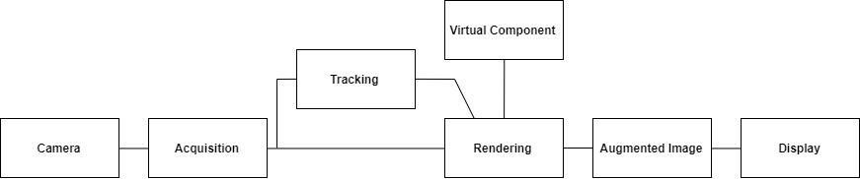

Fig 4.1 Architecture

## 

## **4.2. Detailed Design**

### **4.2.1 System Design**

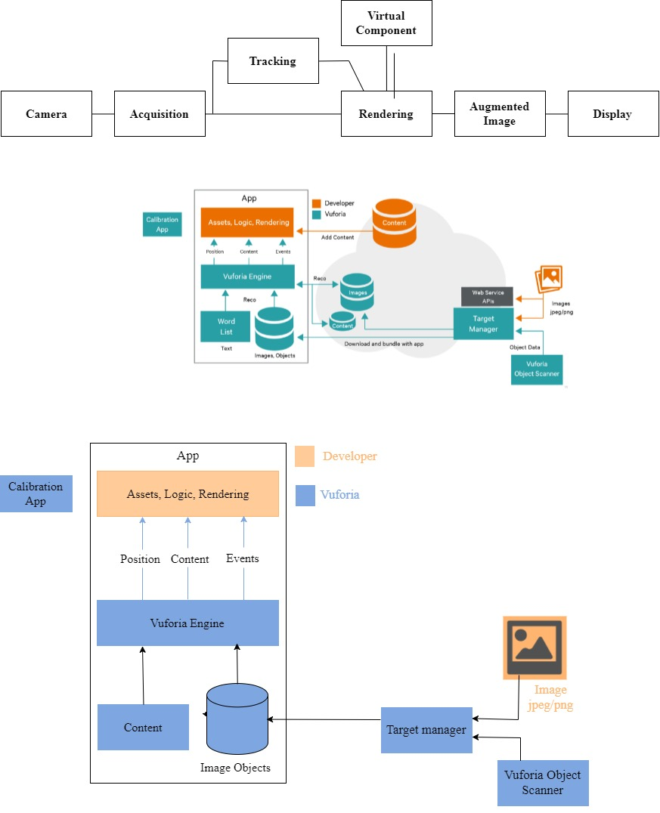

4.2.1 System Design

### 

### 

### 

### 

### 

### 

### 

### 

### 

### 

### **4.2.2 Flow Chart**

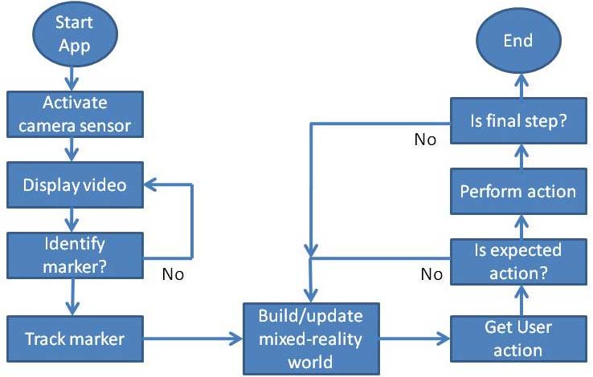

Fig 4.2.2 Flow Chart

### 

### 

### 

### 

### 

### 

### 

### 

### 

### 

### 

### 

### 

### 

### 

### 

### **4.2.3 State Transition Diagram**

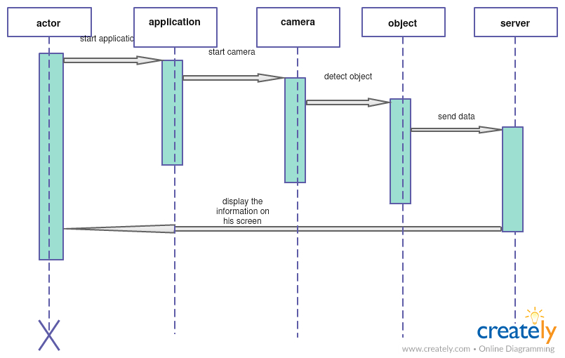

Fig 4.2.3 State Transition Diagram

# 

# 

# 

# 

## 

# **Chapter Ⅴ**

# **Implementation**

## **5.1 Implemented System**

In our proposed system we have explored new ways in which augmented and virtual reality could be used to provide interactive and efficient learning.

1. Learning about historical sites

People love to visit different places with historical values but it involves spending a lot of money and time as well. Even financial conditions can be an obstacle in experiencing human made or natural wonders of the world. AR in tourism can save a lot of time and is available free of cost. By using AR, one can enjoy the scenic view of historical sites in its true form while sitting at home. Also, an audio could be played along with visual effects which will give info about the historical importance of that place.

1. Story Telling

Kids are always eager to listen to stories. But it would be more fascinating and indulging for them if their favourite characters would come alive and act in front of them. AR Storytelling brings alive characters which will tell their own stories in interactive manner. Through ‘AR Storytelling’, imagination skill of kids improves which might help them in future.

1. Engineering Drawing Models for students

A compulsory subject for all engineering students, Engineering Drawing turns out to be a nightmare because of its complex 3d models. Students are not able to imagine the 3d models just by looking at the 2d drawing of the 3d model. AR in Engineering Drawing will help the students to imagine the models in real world 3d space. The AR models available will be for specific problems, but it will help the students to get an idea about other similar problems.

1. Painted Cube Problem

Painted Cube is a classic logical problem in which we take a cube and paint it on all sides and cut it into pieces. For e.g. 3*3*3 sided cube is cut into 27 small pieces. Then we are asked to calculate number of cubes with three sides, two sides, one side and no side painted cubes. It is quite simple for a simple cube but becomes complicated when we cut small cubes from big one and then paint it. Students find it difficult to imagine how the cube would appear when small cubes are removed. By introducing AR in the painted cube problem, students will get an idea of how that cube might look like. Specific Problems will help the students to imagine the cube for other specific problems.

## 

## 

## 

## 

## 

## 

## **5.2 Code Snippets**

**5.2.1 Audio File**

// Code to add audio file in the scene

using UnityEngine;

namespace Vuforia

{

/// <summary>

/// A custom handler that implements the ITrackableEventHandler interface.

/// </summary>

public class DefaultTrackableEventHandler : MonoBehaviour,

ITrackableEventHandler

{

#region PRIVATE_MEMBER_VARIABLES

private TrackableBehaviour mTrackableBehaviour;

#endregion // PRIVATE_MEMBER_VARIABLES

public AudioSource voice;

#region UNTIY_MONOBEHAVIOUR_METHODS

void Start()

{

mTrackableBehaviour = GetComponent<TrackableBehaviour>();

if (mTrackableBehaviour)

{

mTrackableBehaviour.RegisterTrackableEventHandler(this);

}

//Register / Add the AudioSource as object

}

#endregion // UNTIY_MONOBEHAVIOUR_METHODS

#region PUBLIC_METHODS

/// <summary>

/// Implementation of the ITrackableEventHandler function called when the

/// tracking state changes.

/// </summary>

public void OnTrackableStateChanged(

TrackableBehaviour.Status previousStatus,

TrackableBehaviour.Status newStatus)

{

if (newStatus == TrackableBehaviour.Status.DETECTED ||

newStatus == TrackableBehaviour.Status.TRACKED ||

newStatus == TrackableBehaviour.Status.EXTENDED_TRACKED)

{

OnTrackingFound();

voice.Play();

}

else

{

OnTrackingLost();

voice.Stop ();

}

}

#endregion // PUBLIC_METHODS

#region PRIVATE_METHODS

private void OnTrackingFound()

{

Renderer[] rendererComponents = GetComponentsInChildren<Renderer>(true);

Collider[] colliderComponents = GetComponentsInChildren<Collider>(true);

// Enable rendering:

foreach (Renderer component in rendererComponents)

{

component.enabled = true;

}

// Enable colliders:

foreach (Collider component in colliderComponents)

{

component.enabled = true;

}

Debug.Log("Trackable " + mTrackableBehaviour.TrackableName + " found");

}

private void OnTrackingLost()

{

Renderer[] rendererComponents = GetComponentsInChildren<Renderer>(true);

Collider[] colliderComponents = GetComponentsInChildren<Collider>(true);

// Disable rendering:

foreach (Renderer component in rendererComponents)

{

component.enabled = false;

}

// Disable colliders:

foreach (Collider component in colliderComponents)

{

component.enabled = false;

}

Debug.Log("Trackable " + mTrackableBehaviour.TrackableName + " lost");

}

#endregion // PRIVATE_METHODS

}

}

**5.2.2 Start Story**

//on click play button of story then story scene should open

//code to open story scene

using System.Collections;

using System.Collections.Generic;

using UnityEngine;

using UnityEngine.SceneManagement;

public class start_story : MonoBehaviour {

// start_scene_storyfinal function

public void sstart_story(){

SceneManager.LoadScene ("storyfinal");

}

}

**5.2.3 Start eiffel**

//on click play button of wonders of the world then effeiltower scene should open

//code to open effeiltower scene

using System.Collections;

using System.Collections.Generic;

using UnityEngine;

using UnityEngine.SceneManagement;

public class start_eiffel : MonoBehaviour {

// start_scene_ED function

public void sstarteiffel(){

SceneManager.LoadScene ("effeiltower");

}

}

**5.2.4 Start ED**

//on click play button of engineering drawing then ED1 scene should open

//code to open ED1 scene

using System.Collections;

using System.Collections.Generic;

using UnityEngine;

using UnityEngine.SceneManagement;

public class start_ED : MonoBehaviour {

// start_scene_ED function

public void sstartED(){

SceneManager.LoadScene ("ED1");

}

}

**5.2.5 Back**

//on click back button after the respective scene opens goto scene start

//code to goto start scene

using System.Collections;

using System.Collections.Generic;

using UnityEngine;

using UnityEngine.SceneManagement;

public class BACK1 : MonoBehaviour {

public void back1(){

SceneManager.LoadScene ("start");

}

}

**5.2.6 DefaultTrackableEventHandlerED**

**//**code to track marker and to render virtual object on it

using UnityEngine;

namespace Vuforia

{

/// <summary>

/// A custom handler that implements the ITrackableEventHandler interface.

/// </summary>

public class DefaultTrackableEventHandlerED : MonoBehaviour,

ITrackableEventHandler

{

#region PRIVATE_MEMBER_VARIABLES

private TrackableBehaviour mTrackableBehaviour;

#endregion // PRIVATE_MEMBER_VARIABLES

//public AudioSource voice;

#region UNTIY_MONOBEHAVIOUR_METHODS

void Start()

{

mTrackableBehaviour = GetComponent<TrackableBehaviour>();

if (mTrackableBehaviour)

{

mTrackableBehaviour.RegisterTrackableEventHandler(this);

}

//Register / Add the AudioSource as object

}

#endregion // UNTIY_MONOBEHAVIOUR_METHODS

#region PUBLIC_METHODS

/// <summary>

/// Implementation of the ITrackableEventHandler function called when the

/// tracking state changes.

/// </summary>

public void OnTrackableStateChanged(

TrackableBehaviour.Status previousStatus,

TrackableBehaviour.Status newStatus)

{

if (newStatus == TrackableBehaviour.Status.DETECTED ||

newStatus == TrackableBehaviour.Status.TRACKED ||

newStatus == TrackableBehaviour.Status.EXTENDED_TRACKED)

{

OnTrackingFound();

//voice.Play();

}

else

{

OnTrackingLost();

//voice.Stop ();

}

}

#endregion // PUBLIC_METHODS

#region PRIVATE_METHODS

private void OnTrackingFound()

{

Renderer[] rendererComponents = GetComponentsInChildren<Renderer>(true);

Collider[] colliderComponents = GetComponentsInChildren<Collider>(true);

// Enable rendering:

foreach (Renderer component in rendererComponents)

{

component.enabled = true;

}

// Enable colliders:

foreach (Collider component in colliderComponents)

{

component.enabled = true;

}

Debug.Log("Trackable " + mTrackableBehaviour.TrackableName + " found");

}

private void OnTrackingLost()

{

Renderer[] rendererComponents = GetComponentsInChildren<Renderer>(true);

Collider[] colliderComponents = GetComponentsInChildren<Collider>(true);

// Disable rendering:

foreach (Renderer component in rendererComponents)

{

component.enabled = false;

}

// Disable colliders:

foreach (Collider component in colliderComponents)

{

component.enabled = false;

}

Debug.Log("Trackable " + mTrackableBehaviour.TrackableName + " lost");

}

#endregion // PRIVATE_METHODS

}

}

**5.3 Screenshots**

**5.3.1 Vuforia Developer Portal Homepage**



Fig 5.3.1 Vuforia Developer Portal Homepage

Vuforia Developer Portal is used to store the different databases of Image target and license key as well.

**5.3.2 Vuforia License Key for using Vuforia Technology in Unity**

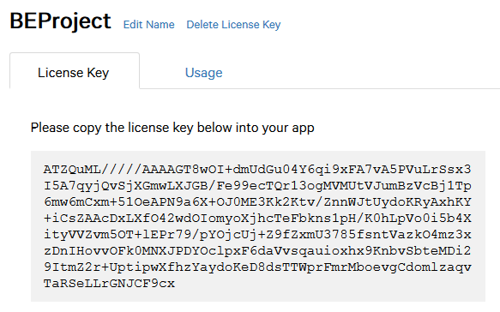

Fig 5.3.2 License Key for using Vuforia Technology

Vuforia license key is used to access the database of Image target in offline mode in Unity.

**5.3.3 Target Manager for Image Database**

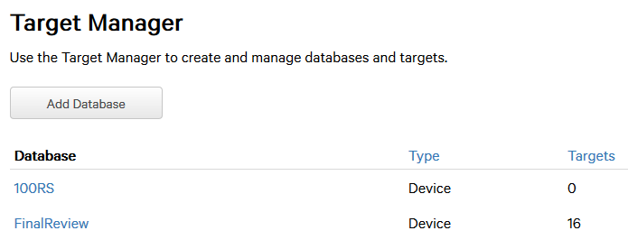

Fig 5.3.3 Target Manager for Image Database

Through Target Manager, one can create and modify Image Database.

**5.3.4 Image Target Database**

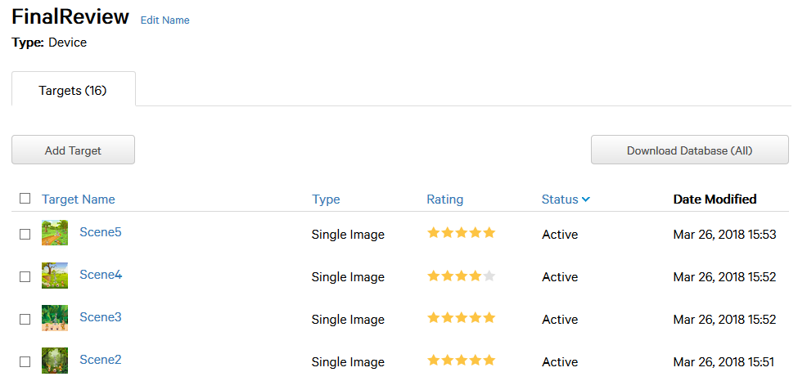

Fig 5.3.4 Image Target Database

In Image Target Database, we add Target Images. Based on the quality of images, They are rated by Vuforia application from 0 to 5. High quality images are easily detected. After adding all the image target, the database is exported as Unitypackage or Android Editor package.

**5.3.5 Assets Manager in Unity Software**

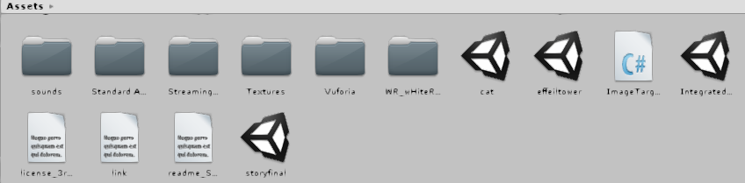

Fig 5.3.5 Asset Manager in Unity Software

In Unity Software, Assets Manager contains all the material required to build the application. These assets include Scripts, 3d models, Audio files, Scenes, Vuforia Configuration Files and all other imported packages.

**5.3.6 Scene in Unity**

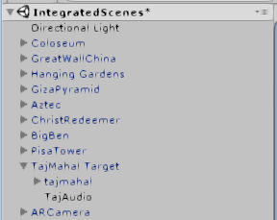

Fig 5.3.6 Scene in Unity

Every Unity Project contains multiple scenes based on multiple scenarios. The required assets are imported into scenes or are placed on the workspace screen.

**5.3.7 Unity Interface for editing the scenes**

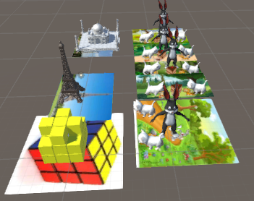

Fig 5.3.7 Unity Interface for editing the scenes

Every asset added to the Scene is reflected on the workspace screen. The models imported on the scene have x,y and z coordinates, scale size and rotation angle.

**5.3.8 Welcome User Interface of application**

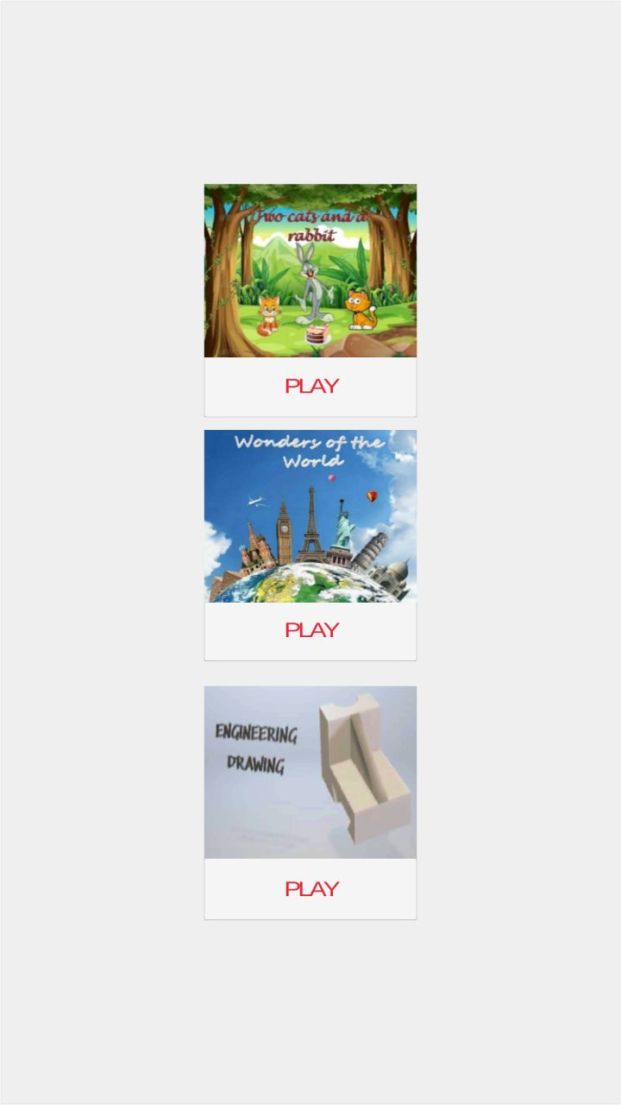

Fig 5.3.8 Welcome User Interface of Application

This is the welcome user interface of application “Exploration”. User willing to see the story will click on story button “Play”, and similarly for other other two applications respective “Play” button below them.

**5.3.9 Storytelling**

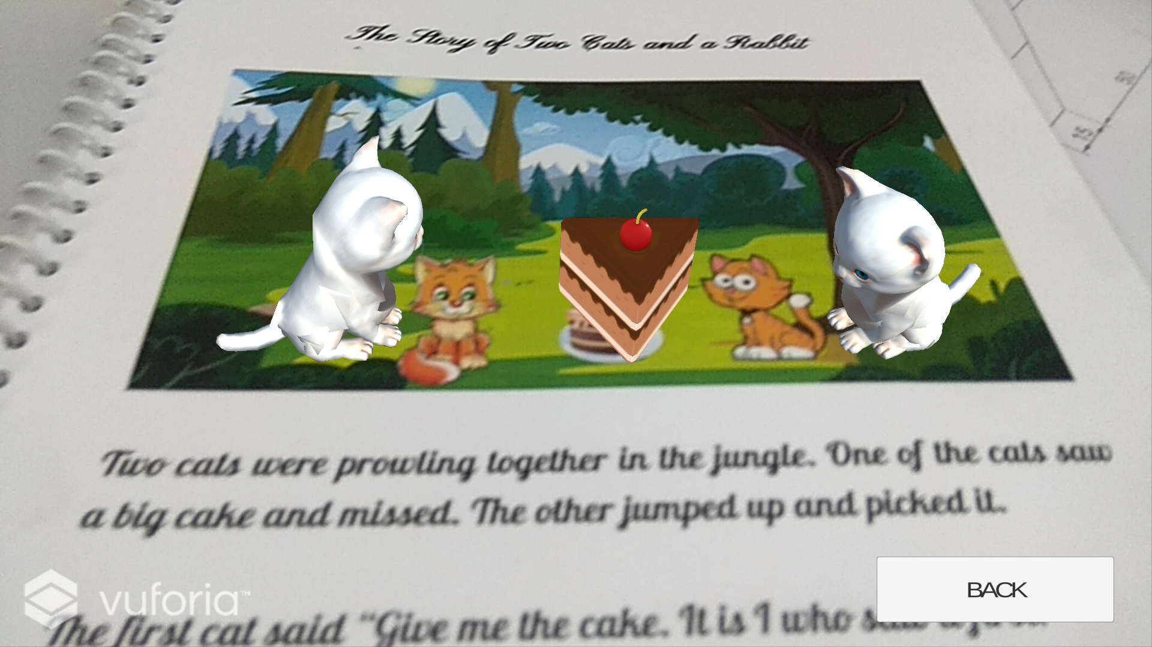

Fig 5.3.9.1 Storytelling(Scene 1)

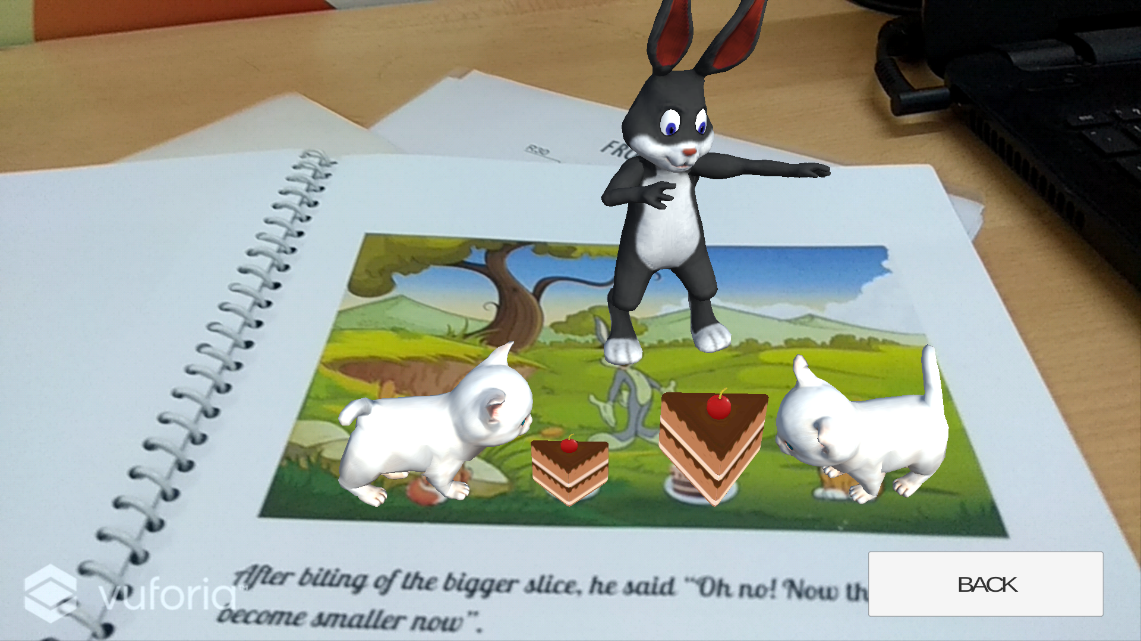

Fig 5.3.9.2 Storytelling(Scene 2)

Animated characters 3D model are projected onto the real world when Image target is detected. User can return to the welcome screen anytime during the playtime by clicking the “BACK” button.

**5.3.10 Tourism of historical sites**

## 

Fig 5.3.10.1 Eiffel Towerprojected on Image Target

## 

Fig 5.3.10.2 Tourism of historical sites

Historical sites 3D model are projected onto the screen when Image target is detected. The model is enlarged when the camera of mobile device is moved closer to image target and vice versa.

**5.3.11 Engineering Drawing**

## 

Fig 5.3.11.1 ED Model(Side-View)

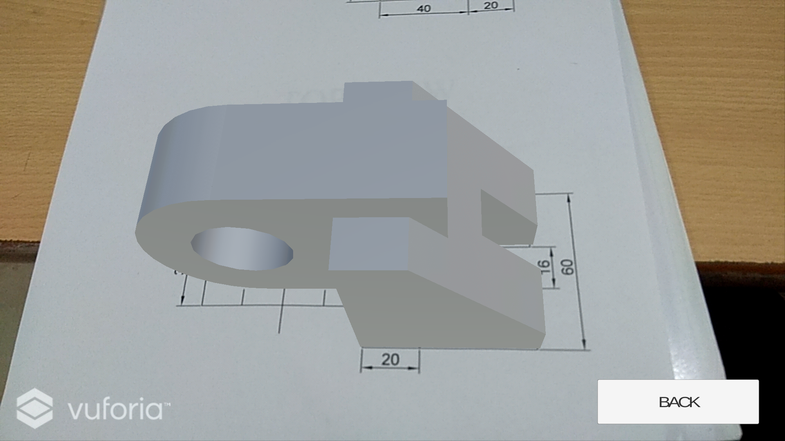

Fig 5.3.11.2 ED Model(Top-View)

Engineering Drawing models are projected onto the front and top view of ED diagrams.

**5.3.12 Painted Cube Problem**

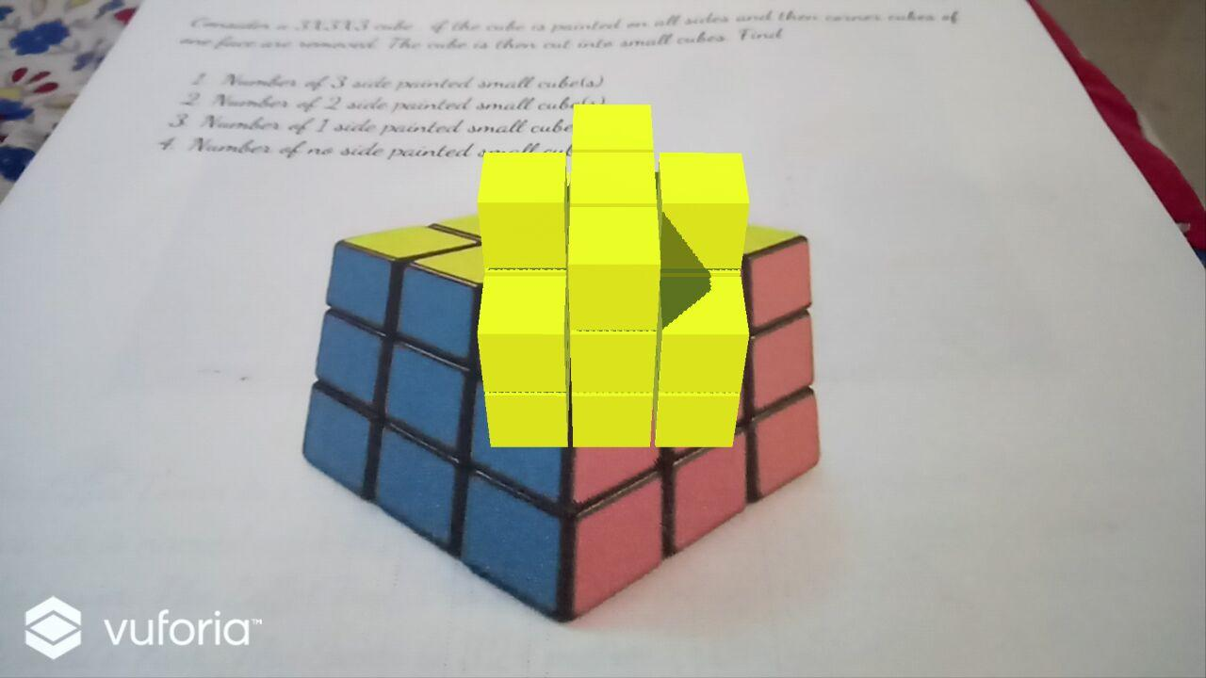

Fig 5.3.12 Painted Cube is projected on Image Target

The visual representation of painted cube is projected on the Image target of cube.

**Chapter Ⅵ**

# **Conclusion**

Augmented and Virtual reality have many applications in every field of sciences like Education, Medical, Military, Tourism, Architecture, Interior design and much more. They both are used to solve real-life problems in day to day life. In this project, we have explored various ways in which Augmented reality can be used in education to make it more creative, interactive and efficient. Tourism of historical sites through AR technology and learning about their rich culture and history. Storytelling through animated characters which speak their own tales helps the kids to develop visualization skills at early age. Engineering Students find it difficult to visualize the ED diagrams in 3D space.AR technology in ED diagrams helps the student to visualize the models in 3D space which can help in future for other similar problems.Painted Cube is a classic logical problem which can improved using AR technology by helping students visualize the complex painted cube and hence find the solution. Currently, AR technology is mostly used in entertainment and military sector but it has a large scope in Education field as well and we have explored some of those applications.

# **References**

1. [1] Mehdi Mekni, Andre Lemieux(2014). Augmented Reality: Applications, Challenges and Future Trends. International Conference on Applied Computer and Applied Computational Science. pp 205-214. ISBN 978-960-474-368-1.
2. [2] Nor Farhah Saidin1, Noor Dayana Abd Halim, Noraffandy Yahaya1 (June 25, 2015). A Review of Research on Augmented Reality in Education: Advantages and Applications. International Education Studies; Vol. 8, No. 13. ISSN 1913-9020 E-ISSN 1913-9039
3. [3] Brian Boyles(2017). Virtual Reality and Augmented Reality in Education. CTE United States Military Academy.
4. [4] Ronald Azuma, Yohan Baillot, Reinhold Behringer, Steven Feiner, Simon Julier, Blair MacIntyre (November 2001). Recent Advances in Augmented Reality. IEEE Computer Graphics and Applications. pp 34-47
5. [5] Ronald T. Azuma(August 1997). A Survey of Augmented Reality. Teleoperators and Virtual. pp 355-385.
6. [6] Antti Ajanki, Mark Billinghurst, Hannes Gamper, Melih Kandemir, Samuel Kaski, Markus Koskela, Mikko Kurimo, Teemu Ruokolainen, Timo Tossavainen(June 2011). An Augmented Reality Interface to Contextual Information. Virtual Reality. pp 161-173. ISSN: 1359-4338.
7. [7] Peng Chen, Xiaolin Liu, Wei Cheng, Ronghuai Huang(September 2016). A review of using Augmented Reality in Education from 2011 to 2016. Innovations in Smart Learning. pp 13-18.
8. [8] Stephanie Fleck, Martin Hachet, J.M. Christian Bastien(May 2015). Marker-based augmented reality: Instructional-design to improve children interactions with astronomical concepts. Interaction Design and Children(IDC) 2015. pp 21-28.
9. [9] Jaewoon Lee, Yeonjin Kim, Myeong-Hyeon Heo, Dongho Kim, Byeong-Seok Shin(February 2015). Real-Time Projection-Based Augmented Reality System for Dynamic Objects in the Performing Arts. Advanced Symmetry Modelling and Services in Future IT Environments. pp 182-192
10. [10] Alexandru Gherghina, Alexandru-Corneliu Olteanu, Nicolae Tapus(January 2013). A Marker-Based Augmented Reality System for Mobile Devices. 11th Roedunet International Conference (RoEduNet) 2013.
11. [11] Yann Argotti, Larry Davis, Valerie Outters, Jannick P. Rolland(October 2001). Dynamic Superimposition of Synthetic Objects on Rigid and Simple-Deformable Real Objects.IEEE and ACM International Symposium on Augmented Reality (ISAR'01).

# 

**Acknowledgment**

We are thankful to our college Vivekanand Education Society’s Institute of Technology for considering our project and extending help at all stages needed during our work of collecting information regarding the project.

It gives us immense pleasure to express our deep and sincere gratitude to Assistant Professor Mrs. Smita Jangale (Project Guide) for her kind help and valuable advice during the development of project synopsis and for her guidance and suggestions.

We are deeply indebted to Head of the Information Technology Department Dr.(Mrs.) Shalu Chopra and our Principal Dr. (Mrs.) J.M. Nair , for giving us this valuable opportunity to do this project.

We convey our deep sense of gratitude to all teaching and non-teaching staff for their constant encouragement, support and selfless help throughout the project work. It is great pleasure to acknowledge the help and suggestion, which we received from the Department of Information Technology.

We wish to express our profound thanks to all those who helped us in gathering information about the project. Our families too have provided moral support and encouragement at several times.